Discussion Forum Unit 6

In Python, objects and values form a basis of Python programming and are fundamental when it comes to distinguishing the variables and their interaction. "Equivalent" and "identical" are terms that define values and objects.
Equivalent means two things that have the same value, but are not necessarily the same object. As Downey, 2015, explains: “we would say that the two lists are equivalent, because they have the same elements, but not identical, because they are not the same object. If two objects are identical, they are also equivalent, but if they are equivalent, they are not necessarily identical.”
Identical refers to two variables that reference the same object in memory. Downey, 2015, explains: “identical: Being the same object (which implies equivalence).”
Here’s an example to illustrate it:
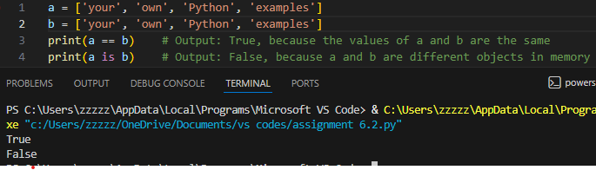
In this example, both lists a and b are equal (hold the same elements), but they are not exactly the same because they are not the same entity in the memory. Using ==, I checked if the values are the same, so a == b returns True. However, the is operator checks if both variables reference to the same object in memory, and because “a” and “b” are different objects in memory with the same content, a is b returns False. Downey, 2015, explains: “To check whether two variables refer to the same object, you can use the is operator.”
In Python, objects can be allocated in memory and can be referenced by one or more variables. A variable points to an object via a reference, which basically refers to the linkage between a variable and an object in memory. In aliasing, two or more variables can refer to the same object.
Here’s an example to illustrate it:
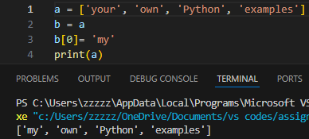
In this example, “a” and “b” are aliases for the same list. When the element in “b” changes (with b[0] = ‘my’), it changes the element in “a” as both “a” and “b” are referring to the same memory location. Downey, 2015, explains: “If a refers to an object and you assign b = a, then both variables refer to the same object”.
In Python, when calling a function with the list as an argument, the function actually receives a reference to the initial list. This implies that any changes done to the list during the execution of the function will have an effect on the original list.
Here’s an example to illustrate it:
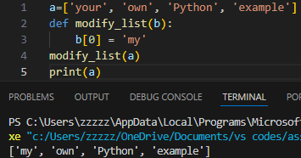
In this example, the list ‘a’ is passed to the modify_list() function, and the first element in the list is changed, because I chose index 0 in “b[0]”. The change made inside the function (modifying the first element) affects the list outside the function as well. This behavior demonstrates that when I pass a mutable object (like a list) to a function, I am passing a reference, not a copy. Downey, 2015, explains, "When you pass a list to a function, the function gets a reference to the list".

Discussion Question
Have you ever run into problems when passing lists or other mutable objects to functions in Python? How do you think understanding references and aliasing can help avoid unexpected changes to your data? Do you have any tips on how to prevent those issues?
References
Downey, A. (2015). Think Python: How to think like a computer scientist. Green Tea Press. https://greenteapress.com/thinkpython2/thinkpython2.pdf

